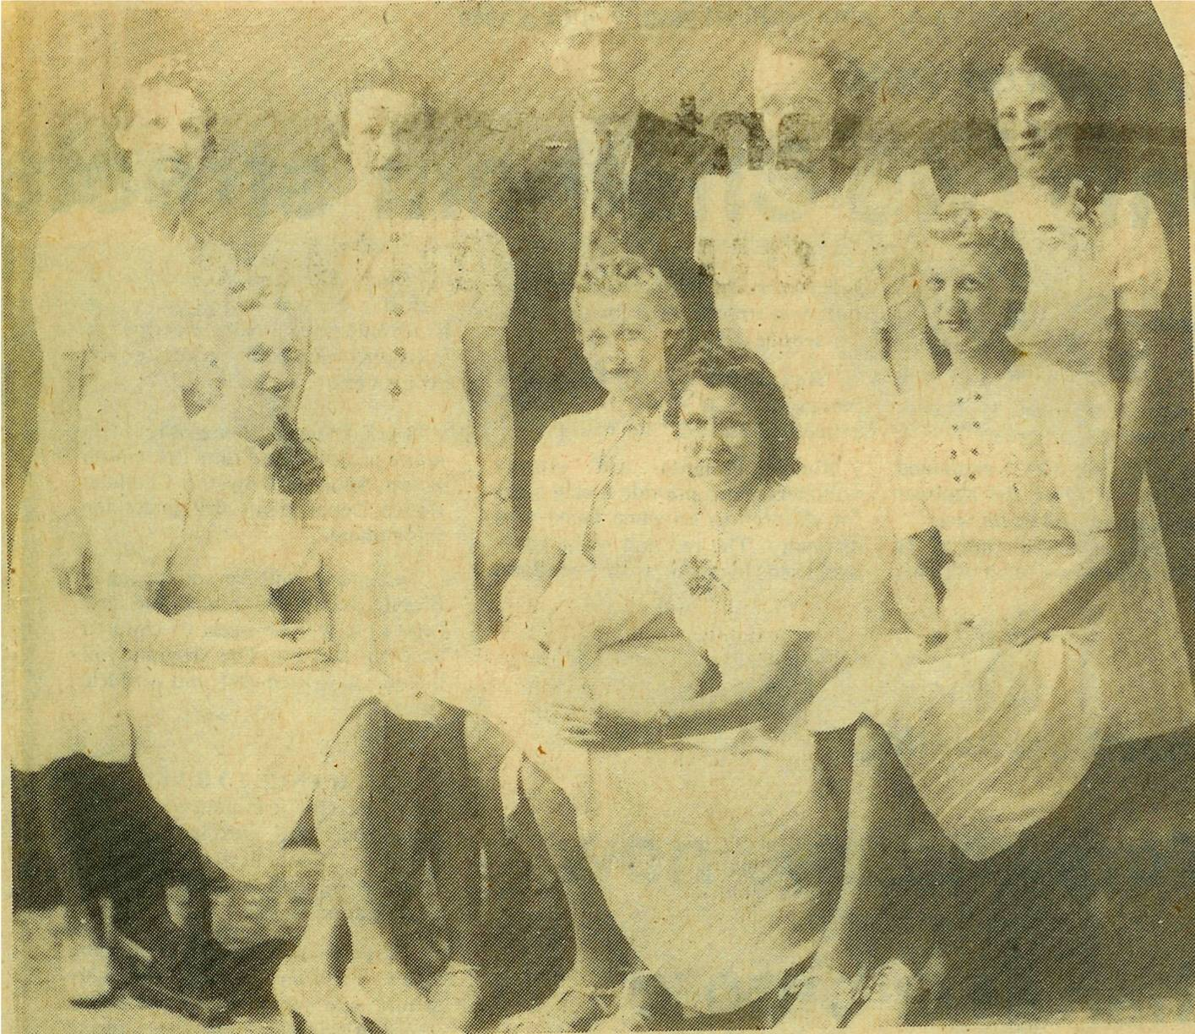

Above is a photo of the first graduating class at the Miramichi Rural High School in June 1940. Back row, left to right: Ivy Kingston, Anna Williston, Peter Kingston, Evelyn Chapman and Catherine MacLean. Front row: Emily Smith, Alvena Smith, Opal Fraser and Marion Smith. Graduates would have commenced studies at St. John’s Anglican Church in Bay du Vin

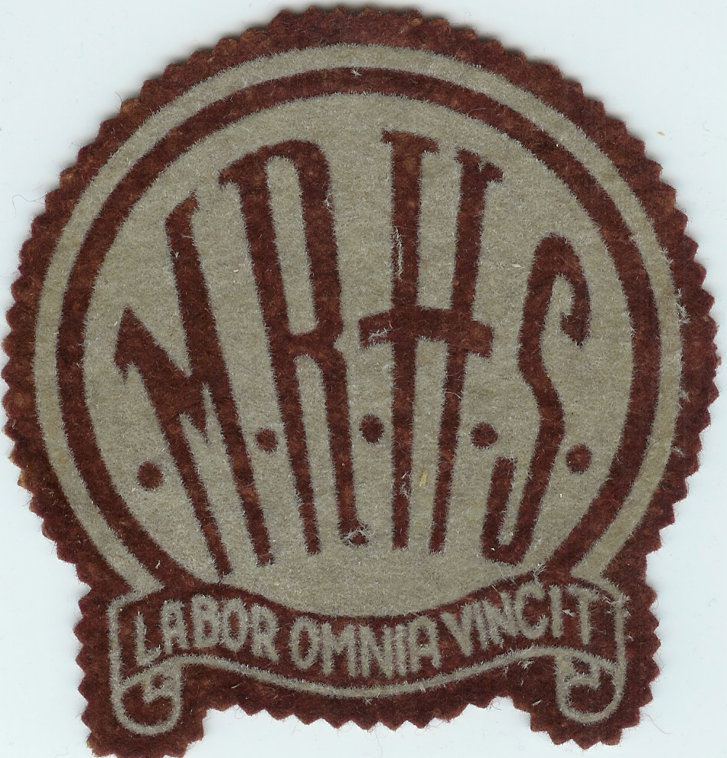

Miramichi Rural High School crest. “Labor Omnia Vincit” means ”Labour Conquers All” or “Labour Overcomes All Difficulties” The Miramichi Rural High School commenced classes in January, 1940 and was officially opened later that year.

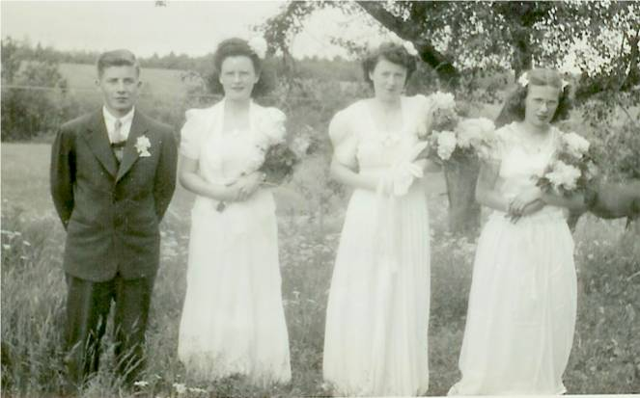

MRHS Graduation 1945
From left: George Watling, Joan MacDonald, Mary MacDonald and Frances MacLean

Graduation Photos

George Watling tells me that the above
photo was taken at the home of Frances MacLean. Perley Quayle, Principal of MRHS, drove the graduates to the MacLean home in his Model A Coupe. George rode in the rumble seat.

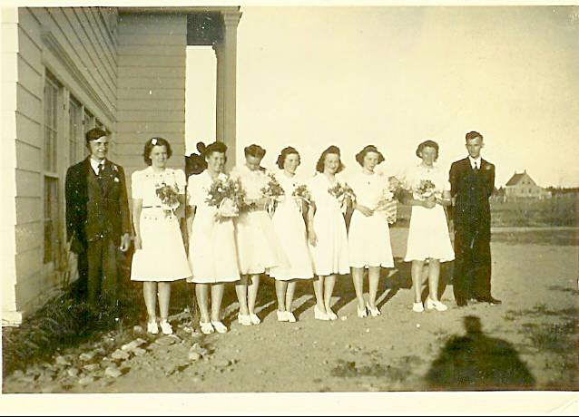

Miramichi Rural High School Graduating class in 1942. From left to right: Ken Glendenning, Lorna Watling, Bertha Fowlie, Isobel Williston, Jennie MacLean, Shirley MacDonald, Edith MacRae and Billy Gulliver

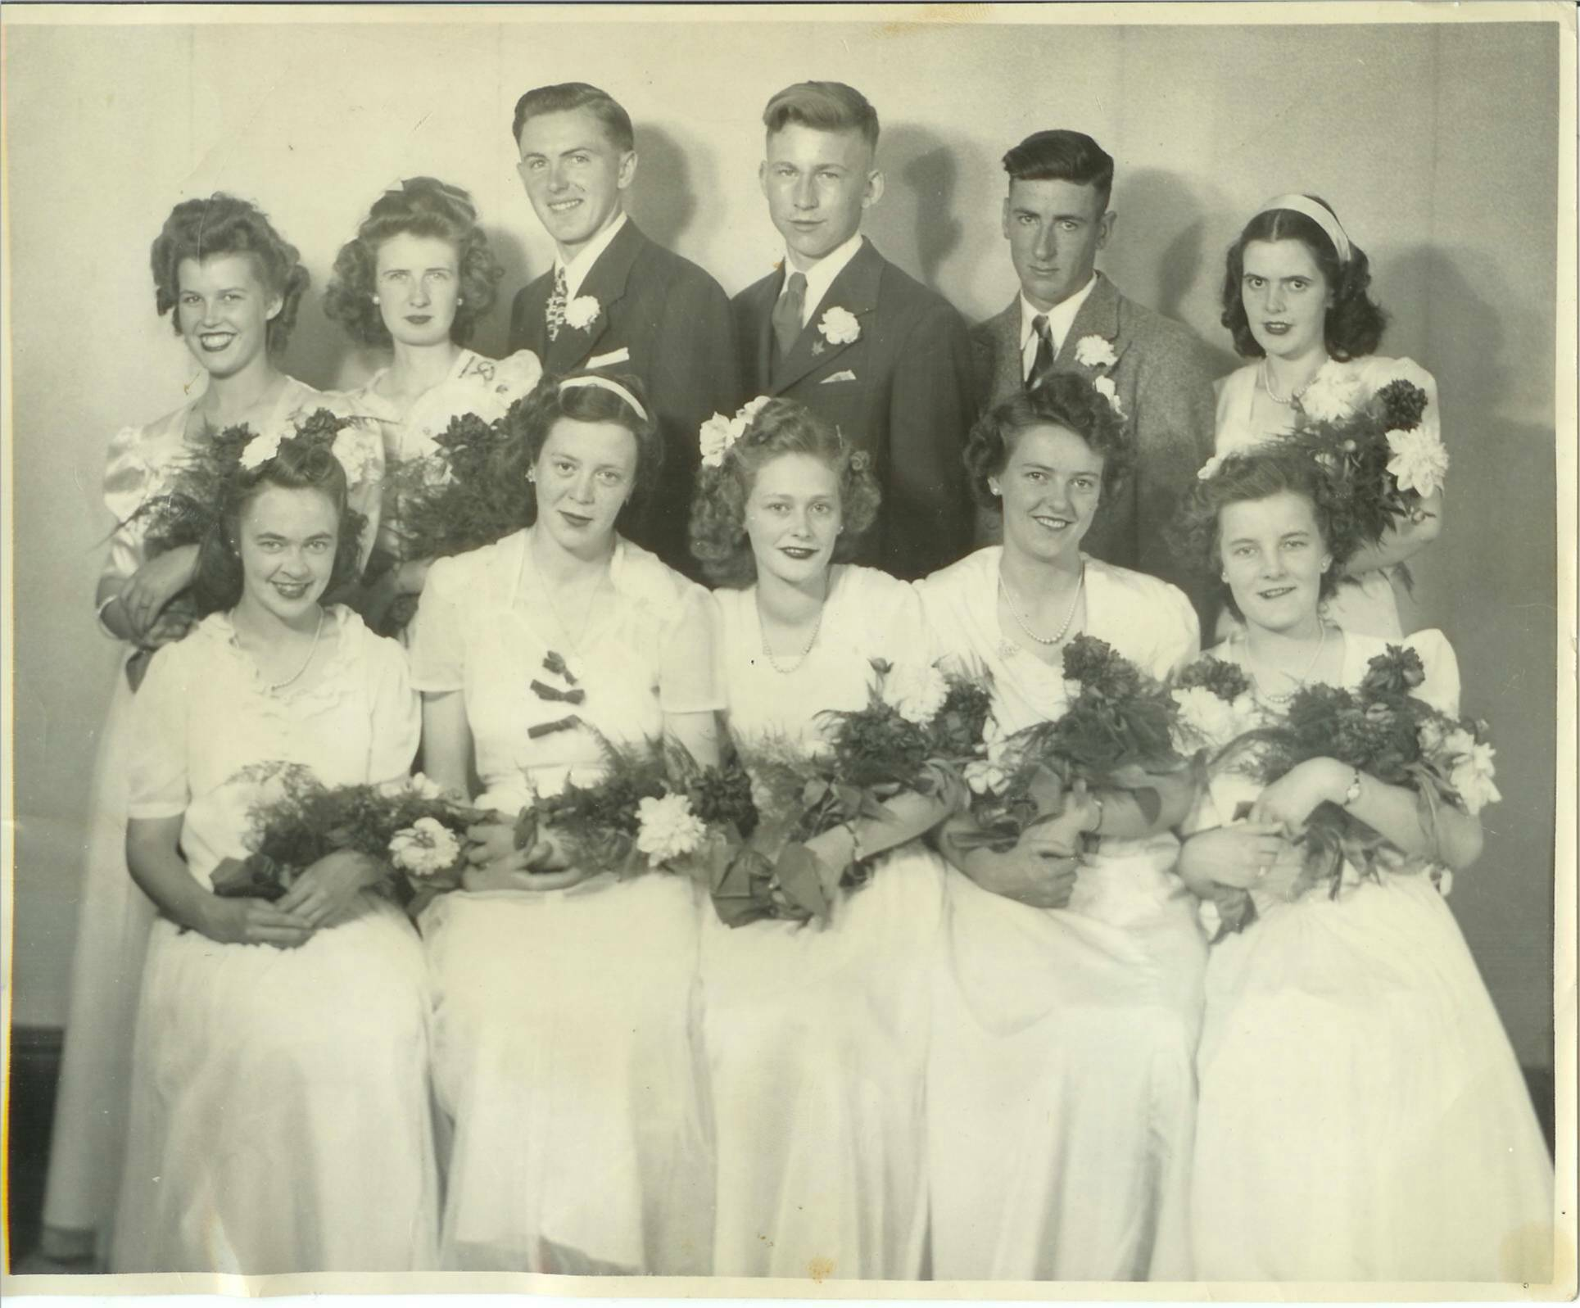
MRHS Graduating Class of 1946: Front Row: Helen MacNaughton, Flora Kingston. Helen MacRae, Ellen MacLenaghan and Kathleen MacRae. Back Row: Mary Johnston, Vera Cameron, Robert Dutcher, Don Glendenning, Bill Gregan and Norma Williston, (Ed: This has to be the finest looking group of all)

